

**ECE 5734**

Embedded Systems Verification & Validation

**Project Progress Report on**

VERIFICATION OF SAFETY REQUIREMENTS IN AUTONOMOUS VEHICLE

**By**

Cory Ness

Kokila Subramanian

**Under the Guidance of**

Professor Ramesh Sethu

Winter 2022

**Table of Contents**

**Abstract** 2

**Introduction** 3

**Objective of Project** 4

**Safety Requirements** 4

**Kinematics and Dynamic Autonomous Vehicle Model using LabVIEW** 5

Model Based Car Simulation 5

Test Generator 6

Top Level- Verification Dashboard 7

**Verification of Safety Requirements Test Cases** 7

Drive Straight Ahead at 60 MPH 7

Turn 360° 9

Lane Change 10

Avoid Obstacle 11

Figure 8 12

Back-in parking 13

**Accomplishments in the project** 14

**Points of further development** 14

**Conclusion** 15

**References** 16

# **Abstract**

An autonomous vehicle system is a very complex system, involving the interaction of onboard intelligent computing systems, a range of sensors, radars, and electromechanical parts. The society of Automotive Engineers (SAE) has defined various standards to define the automation level of vehicles. Based on the standards and levels defined, an autonomous vehicle can perform an entire or part of the Dynamic Driving Task (DDT). The self-driving transportation system should be designed to operate without human interference, in coordination with perception, decision & control, and vehicle platform manipulation functions based on both the internal system and external environment. Modeling an autonomous vehicle includes safety as a key property that is interdependent with other self-driving features to protect the vehicle and environment from accidental failures and attacks.

The objective of the project is to develop a model and verify the functional requirements of the autonomous vehicle systems using the LabVIEW simulation tool. The autonomous vehicle model is designed based on physics and mimics the sensors that a real vehicle would see on the road. It will include such sensors as wheel velocity sensors to measure the vehicle's current velocity, distance measurement sensors to measure the distance to cars in front of and behind the vehicle, and lane centering sensors to measure how far from the center of the lane the vehicle is. Using the sensors from the model, the automated driving program will drive actuators in the model which will change inherent properties, such as acceleration, velocity, and center-lane position, and verify these properties are within acceptable parameters for the test. The requirements for the system centered on safety measures such as automatic braking system, accidental failure, and hazard analysis reliant on SAE Automation levels are to be identified and added to the developed vehicle model. The project aims at verification and validation of safety requirements and targets by incorporating safety countermeasures to ensure consistency of the autonomous transportation system.

# **Introduction**

The concept of connected devices and cooperative and intelligent self-driving transportation systems are thriving in the economy over the past decade. The society of Automobile engineering (SAE) has defined 5 levels of automation depending on their functionalities and capabilities. Today's commercially available autonomous vehicle systems have reached the 4th level of autonomy. The major constraint of an autonomous vehicle in urban traffic should be capable of navigating through the varying city’s traffic conditions, performing complex maneuvers like parking, moving at intersections, merging in a lane, and must operate with the diverse geographical boundary conditions. Verification and validation of the safety requirements of the system can add trustworthiness to the autonomous system under development.

# **Objective of Project**

This project aims to develop a model and verify the functional requirements of an autonomous vehicle system using the LabVIEW simulation tool. The autonomous vehicle model developed was based primarily on physics and research done by others, which we implement in LabVIEW. To identify the safety requirements of an autonomous driving system that includes obstacle detection, maintaining stability, automatic transmission control, and accidental failure prevention. Using the model, it is attempted to drive the vehicle based on the safety requirements of the currently running test and verify that the model’s outputs are within acceptable safety criteria for the test that’s running.

# **Safety Requirements**

Understanding the autonomous vehicle model, the dynamic behavior, and evaluating the functionalities involves two wide processes, verification and validation, implemented from the early stage of the product development. The safety requirements definition for autonomous vehicles are listed under the following factors:

* Determine the current location of the vehicle with the use of perceptional sensors and environmental conditions.
* Perceive relevant static and dynamic objects in proximity using the traffic condition and sensor data and predict the future behavior of surrounding objects from the perceived data.
* Create a collision-free and lawful driving plan by interpreting the information collected from the environment and ADS manager and using it to control the actuators.
* Ensure Controllability of Vehicle with seamless braking, lane control, and object detections capabilities in coordination with surrounding vehicles.

# **Kinematics and Dynamic Autonomous Vehicle Model using LabVIEW**

## **Model Based Car Simulation**

The kinematics and dynamics of the Car simulator model are developed using the LabVIEW simulation tool. It provides the physical variables of the autonomous vehicle based on the inputs over simulation time. The model was generated concerning the vehicle model equations provided by the authors in “Kinematic and Dynamic Vehicle Models for Autonomous Driving Control Design”. However, the implementation of the models in LabVIEW was developed from scratch in this project and is shown in the figure below.

Figure 1. Car Simulator Block Diagram

The car simulation model mimics the sensors present in a real-time vehicle to monitor the acceleration, distance with other surrounding vehicles, rear sensors, and lane centering sensors to sustain the vehicle in its path. Using the Kinematics model, the vehicle mechanics are analyzed concerning the geometrical motion of the body or system of bodies without considering the cause or effect involved. It is an effective model to capture the vehicle velocity is tangent to the current path (Kong, et.al., n.d). Dynamic modeling is more involved and is used to precisely capture the behavior of the vehicle over a wide operating range. The inputs such as wheel speed control, direction, steering control, friction, steering angle radians, and brake control, are used to drive the vehicle model. The physical properties of the vehicle such as acceleration, velocity, position, and direction of the movement of the vehicle can be obtained as the output of the Car simulation model.

## **Test Generator**

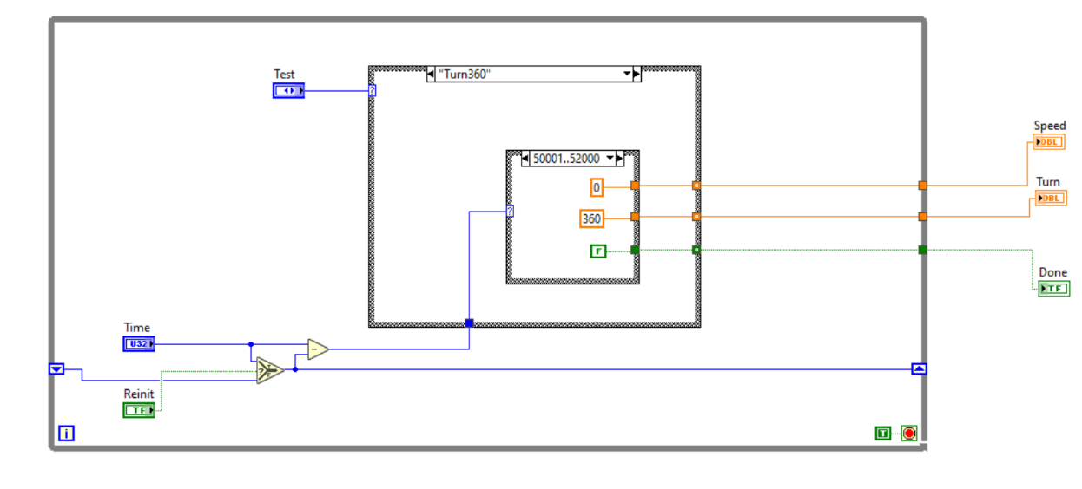The Test Generator is used to select the targets for the model to verify the Test cases for the safety requirements defined as shown in Figure 2. The car simulation model is nested inside the Test generator to execute the specific test on the car simulation model. The test generator block diagram specifies the test cases to run among the various test cases listed. Each test case contains a specific set of inputs, thresholds, and comparison types to verify the requirements and functional correctness of the tests performed. The physical car simulation model developed is positioned inside the closed control loop in the test generator for dynamic supervision.

Figure 2. Test Generator Block Diagram

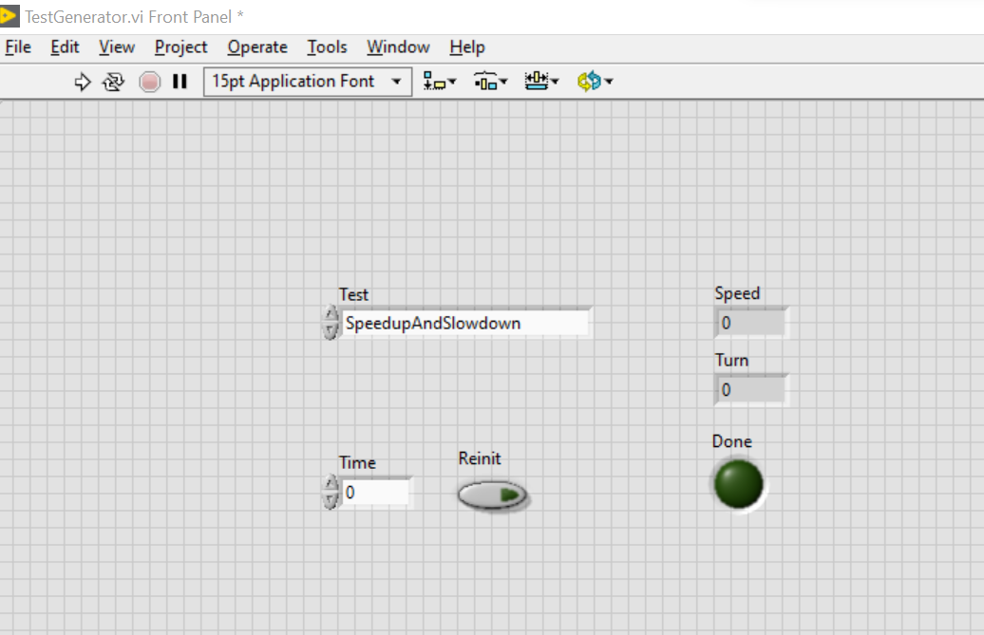The front panel of the Test Generator model, shown in Figure 3, offers the user interface control panel to specify the required test case and the control metrics.

Figure 3. Test Generator Front Panel

## **Top Level- Verification Dashboard**

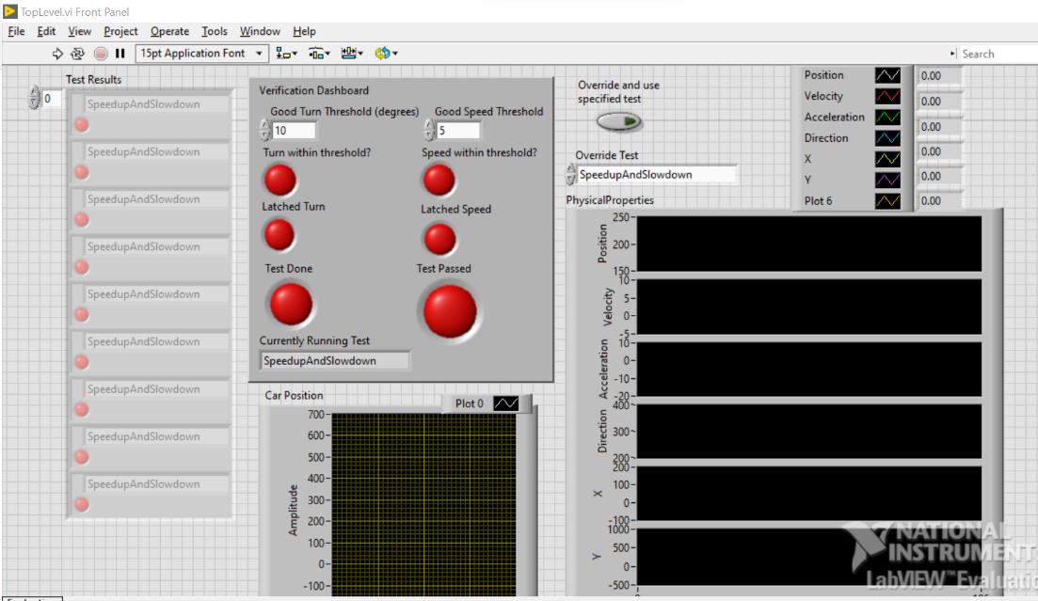The top-level verification dashboard can be modeled based on the user requirements. It has the controls and indicators to specify the threshold levels, the status of the currently running test, and the results for each verification requirement case executed by the test generator. The 2D car position with respect to the X and Y coordinates represents the current direction and position of the vehicle model. The metrics such as position, direction, acceleration, and the velocity of the vehicle are displayed on the dashboard to understand the vehicle's physical properties.

Figure 4. Top Level- Verification Dashboard

# **Verification of Safety Requirements Test Cases**

## **Drive Straight Ahead at 60 MPH**

Before merging into the highway from a ramp, the self-driving vehicle must progress through various levels of autonomous monitoring systems. The vehicle should maintain a specific speed limit before merging to the highway and should overcome the conflict between the vehicle in the mainline and the ramp. The vehicle entering the highway should process multitasking information processing including the information from the surrounding vehicle and should control the task within the limited distance and time with the desired speed limit. It involved synchronized working of the lane centering sensors, velocity sensors, and the co-operative deceleration factor to execute the operation. The drive straight ahead at 60 MPH test executes the following steps:

1. Accelerate the vehicle at the desired speed limit
2. Converge to the main lane
3. 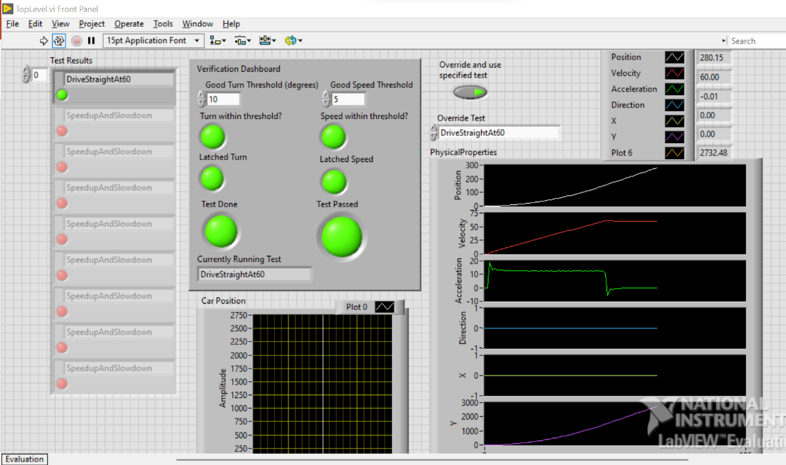Maintain the speed limit in coordination with other aligned vehicles in the lane.

Figure 5. Verification of Passed Drive Straight Ahead at 60MPH Test Case

**Speed Up and Slow Down**

In an urban environment, self-driving cars should encounter any driving conditions from cars, scooters, and pedestrians. And the vehicle should anticipate the traffic condition in 2 to 3 seconds and should perform acceleration and bring the vehicle to stop when necessary. While driving within the city limit, the average maximum speed would be 30MPH, and at this speed, it is easier to bring the vehicle to stop in 2 seconds without hard braking (Staplin, et.al. 2018). The sensors in an autonomous vehicle need to scan the traffic at a distance double the vehicle’s braking distance for safe braking. In the Speed up and speed down test case the following steps are executed to prove the effectiveness of the vehicle to accelerate and decelerate at desired speed when required.

1. Drive straight at the existing speed level.
2. Accelerate the vehicle to 20MPH in addition to the current speed
3. Decelerate the vehicle speed to 0MPH and bring it to a stop.

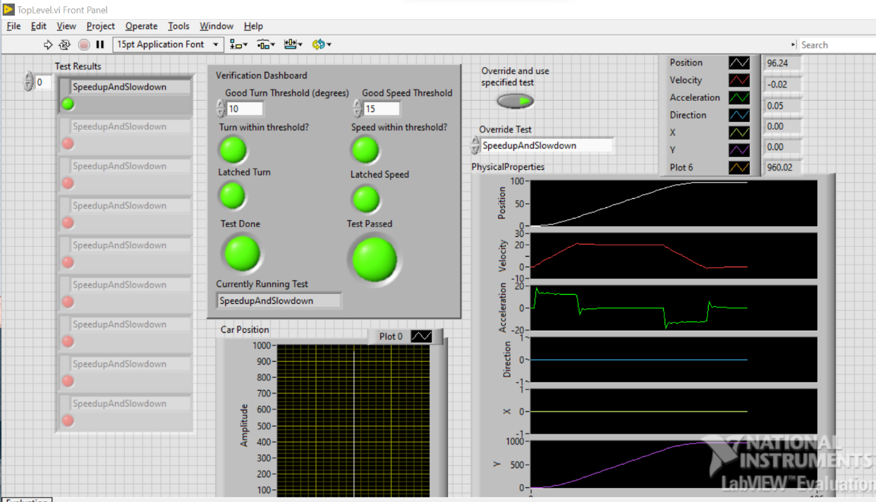 In the verification dashboard, the threshold speed levels are increased and decreased during the test execution to demonstrate the success and the test results turned out to pass for a good speed threshold level of up to 100 MPH. The acceleration and velocity physical parameters illustrate the increase and decrease in the speed level of the vehicle during execution.

Figure 6. Verification of Passed Speed Up and Speed Down test

## **Turn 360°**

Motion control and stability are the key factors for safety in autonomous vehicles. When an autonomous vehicle must make a turn, it involves both longitudinal and lateral movement which involves a complex interaction between plan and Act tasks (Staplin, et.al. 2018). The self-driving vehicle should be capable of determining the right-of-way, initiating and completing a U-turn, navigating through roundabouts, intersections in communicating with other users on the road as necessary. This test mainly focuses on the steering control and steering angle coordination of the vehicle by making a complete 360° turn. The series of actions involved in the turn 360° test case is:

1. Drive straight ahead at less than 10MPH to maintain the stability of the vehicle.
2. Make a left turn depending on the threshold angle value fixed in the verification dashboard.
3. Maintain a constant speed and steering angle to make a complete turn
4. Drive straight ahead.

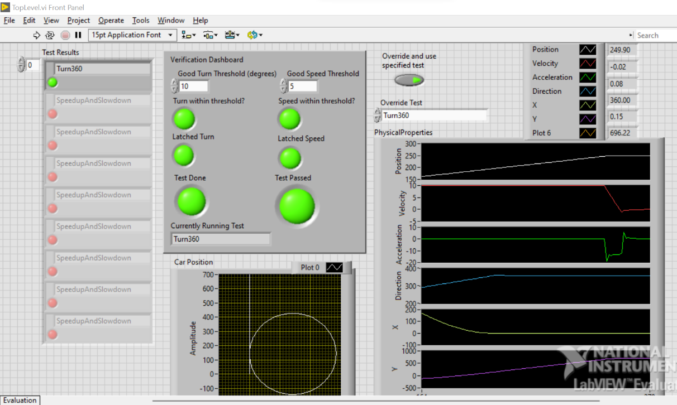

Figure 7. Verification of Passed Turn 360 Degree Test

## **Lane Change**

Automated Lane centering and lane merging operations are becoming key features of the newer model vehicles (Staplin, et.al. 2018). Maintaining the vehicle within the specific lane is performed through lateral control. Lane merging operation is executed based on a projected path and should maintain relative speed with other surrounding vehicles to avoid a collision. Before lane merging the vehicle in motion should identify the vacant lane position and match the speed of other vehicles in the lane. Critical Driving maneuvers include performing a lane change or lower speed lane merge in city limits under heavy traffic conditions. The lane merge or lane change operation involves the following steps:

1. Monitor the speed and distance of the surrounding vehicle
2. Detect empty lane
3. Accelerate if necessary and make the desired turn to move to the intended lane
4. Maintain a safe distance from surrounding vehicles by accelerating or decelerating.

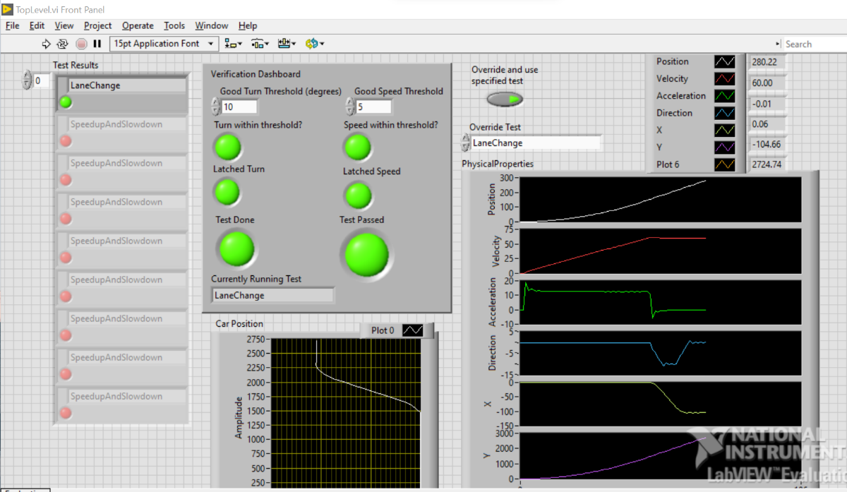

Figure 8. Verification of Passed Lane Change Test

## **Avoid Obstacle**

The self-driving system should act intelligently in identifying and responding to on-road static and dynamic hazards, such as pedestrians, debris, animals, etc. the autonomous model is implemented with an electric shuttle dedicated to implementing smart mobility to adjust its trajectory and speed, leading to obstacle avoidance (Staplin, et.al. 2018). Detection of obstacles occurs in multiple ways like perception sensors including the radar, lidar, cameras, and ultrasonic sensors. They coordinate and assist in the detection and recognition of objects and events. The Avoid Obstacle case is used to verify that the vehicle can appropriately react to an obstacle in front of itself, and maneuver around it, avoiding the collision while still maintaining comfort for the passengers. The Avoid Obstacle test involves the following series of actions:

1. Accelerate to highway speeds
2. Detect static obstacle in Roadway
3. Perform a left-hand turn to avoid the obstacle
4. Perform a right-hand turn to not drive off the road
5. Drive straight as the obstacle passes
6. Perform a right-hand turn to drive back to the desired lane
7. Perform a left-hand turn to be aligned to the lane and drive along with it

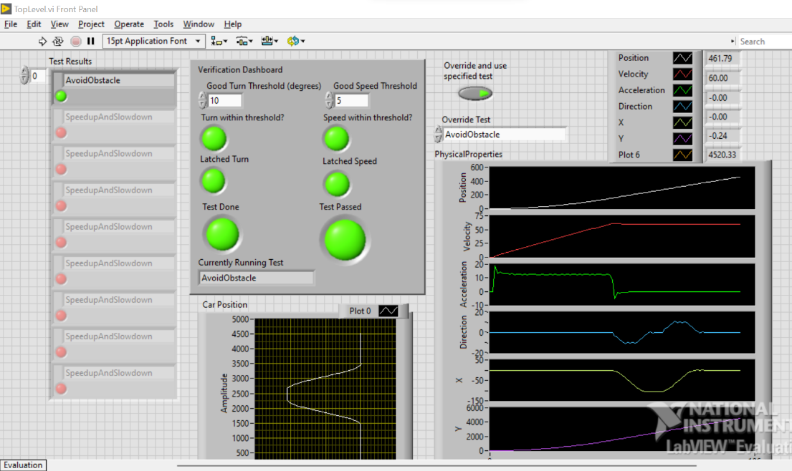

Figure 9: Verification Dashboard for Avoid Obstacle test case

## **Figure 8**

The Figure 8 case is used to verify that the vehicle can accurately perform a complex maneuver that involves both left and right turns. While there isn’t necessarily an analog of this in real life, it stress-tests the system and model by performing a maneuver and helps ensure the system is functional. The Figure 8 test involves the following series of actions:

1. Accelerate to 10mph
2. Perform a right-hand turn to a full 360 degrees
3. Perform a left-hand turn to a full 360 degrees
4. Decelerate back to 0mph

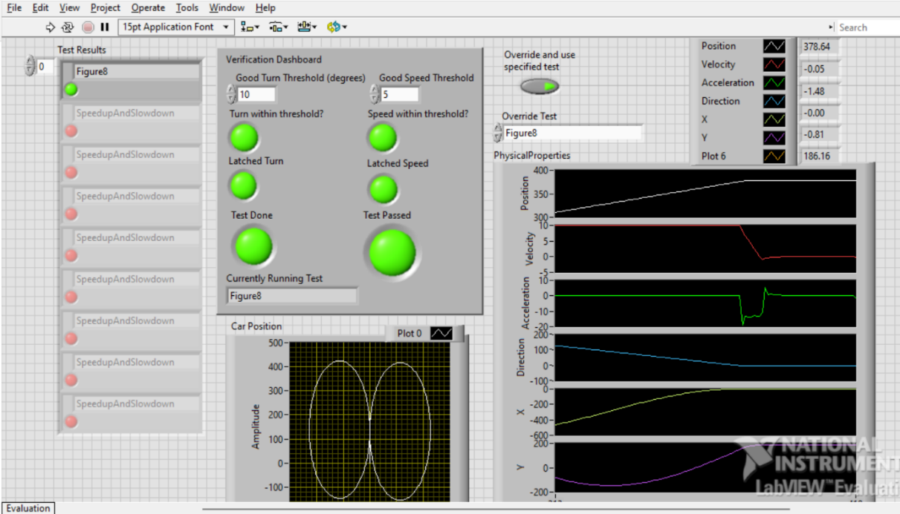

Figure 10: Screenshot of the Figure 8 test case

## **Back-in parking**

Reverse parking is the most critical feature of Autonomous vehicles. The vehicle must identify the vacant slot using the rear image processing system built into the Autonomous Driving system. This includes the coordination of the steering control system and braking system. To successfully park, the autonomous vehicle must perform three important steps to be analyzed such as target position designation, path planning, and path tracking (Tashiro, 2013). The vehicle should make heading adjustments that comprise forward and reverse the movement by adjusting the steering to position in the right lane (Staplin, et.al. 2018). The developed kinematics-based autonomous vehicle model is made to perform the following steps to perfume reverse parking.

1. Drive Straight ahead at 10 MPH
2. Identify the empty parking spot
3. Make a trajectory path planning towards left
4. Make a straight drive and place the vehicle within the lane

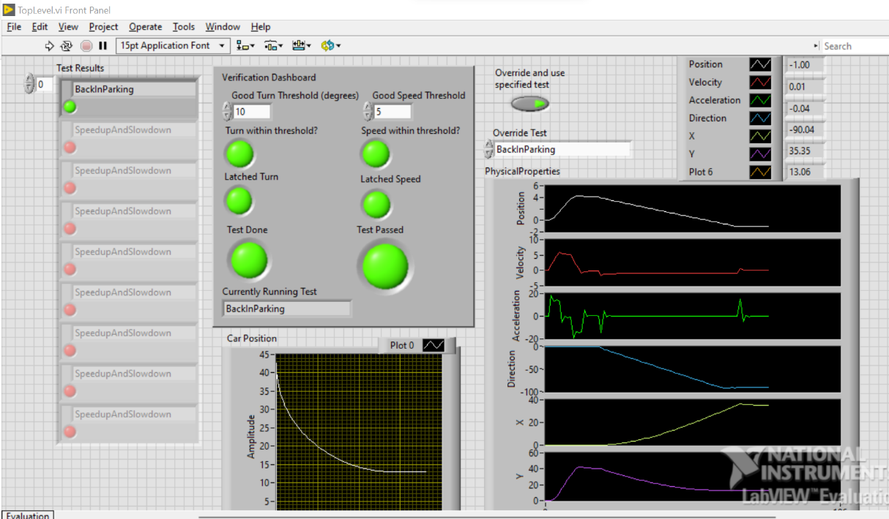

Figure 11. Verification of Passed Back-in Parking Test

# **Accomplishments in the project**

In this project, we have developed a Kinematics based dynamic Autonomous vehicle mode in the LabVIEW simulation tool and verified the safety requirement test cases identified based on the SAE automation level standards. The test cases are implemented in the Test generator module which includes the developed Car simulation module. The verification of each test case can be viewed from the Verification Dashboard organized based on user requirements.

The accomplishments of this project include:

* Successfully developed kinematics and dynamics-based Autonomous vehicle control model.
* Analyzed various safety requirements listed by SAE for Autonomous vehicle models.
* Developed varied test cases that cover most safety requirements for the self-driving vehicle model.
* Verified the fulfillment of each test case implemented.
* Succinct method of verifying the overall system by performing all tests in sequence.

## **Points of further development**

The project can be further enhanced in the future by

* Adding more test cases about other requirement factors.
* Verify the system with more complex scenarios including a wide range of vehicle types, multi-lane, intersections, and varying environmental conditions.
* Can add more monitors to increase the effectiveness of the verification model.

# **Conclusion**

The autonomous vehicle model needs a complementary driving system to human drivers which is enhanced in terms of advanced safety technology. The self-driving system was initially built with an automatic braking system and further enhanced by adding 360° perception, and front and rear video systems. The system is further heightened by features such as driver detection and response, including forwarding collision warning, lane assistance, and other ADS features to enrich the automatic driving experience for users. With the massive development of varied software and system by diverse manufacturers, the need to establish effective communication among other vehicles on the road is an essential feature of a safe driving plan in autonomous vehicles. The basic kinematics and dynamics-based autonomous vehicle model developed in this project is verified to be effective for the common safety requirements listed reliant on the SAE standard. The model implemented in LabVIEW provides a simple way to perceive the test results using the user-friendly interface verification dashboard. The model is proved to be effective in satisfying a wide range of safety requirements recognized for real-world scenarios.

# **References**

1. Ailon, A., Berman, N., & Arogeti, S. (2005). On controllability and trajectory tracking of a kinematic vehicle model. *Automatica*, *41*(5), 889–896. <https://doi.org/10.1016/j.automatica.2004.11.025>
2. Staplin, L., Mastromatto, T., Lococo, K. H., Kenneth W. Gish, K. W., & Brooks, J. O. (2018). The effects of medical conditions on driving performance (Report No. DOT HS 812 623). Washington, DC: National Highway Traffic Safety Administration.
3. *Benz: Safety First for automated driving.* Mercedes. (2019, July 4). https://www.mercedes-benz.com/en/innovation/safety-first-for-automated-driving/?csref=sm_fbk_gims2019_pc.html
4. Kang, C. M., Lee, S.-H., & Chung, C. C. (2018). Multirate Lane-keeping system with kinematic vehicle model. *IEEE Transactions on Vehicular Technology*, *67*(10), 9211–9222. https://doi.org/10.1109/tvt.2018.2864329
5. Kong, G., Pfeiffer, Mark., Schildbach, G., and Borrelli, F. *Kinematic and dynamic vehicle models for Autonomous Driving Control Design*. IEEE Xplore. (n.d.). https://ieeexplore.ieee.org/document/7225830
6. Sabaliauskaite, G., Liew, L., & Cui, J. (1970, January 1). *[PDF] Integrating Autonomous Vehicle Safety and security analysis using STPA method and the six-step model: Semantic scholar*. undefined. https://www.semanticscholar.org/paper/Integrating-Autonomous-Vehicle-Safety-and-Security-Sabaliauskaite-Liew/dcc9ab963f2f4d97b5dc81d0e8df0708008d36a8
7. Tashiro, T. (2013). Vehicle Steering Control with MPC for target trajectory tracking of autonomous reverse parking. *2013 IEEE International Conference on Control Applications (CCA)*. https://doi.org/10.1109/cca.2013.6662766